

**Database System Coursework**

Preeti Shrestha

B.Sc. (Hons). Computing, Softwarica College of IT and E-commerce, Coventry University

ST4005CEM Database System

Gopal Prasad Neupane

January 29th, 2024

Contents

**Introduction** 3

Acknowledgement 4

Entity- Relationship Diagram 5

**Normalization** 6

**SQL of the normalized Tables.** 7

**Data Entry for the Created Tables** 12

**Data Visualization** 18

Figure 1 ; ERD Of Database …………………………………………………………………………………………………………….6

Figure 2: 3NF Form of all Tables 7

Figure 3:Create Database and Use Database 8

Figure 4: (Class, Gender, Address, Guardian) - Table 8

Figure 5(Student, Teacher)- Table 9

Figure 6(Subject, Payment, Result) - Table 10

Figure 7( Exam, Borrow, Book, Attendance) - Table 11

Figure 8(Attendance, Events, Students Enrolled) - Table 12

Figure 9 Gender Entry 13

Figure 10 Guardian Data 14

Figure 11Address Data 14

Figure 12 Class Data 15

Figure 13 Student Data 16

Figure 14 Subject Data 16

Figure 15 Result Data 17

Figure 16 Payment Data 17

Figure 17 Teachers Data 17

Figure 18 Events Data 18

Figure 19 Event Details Data 18

Figure 20 Bar Graph Code 19

Figure 21 Bar Graph representing class and students 19

Figure 22 Line Pot graph code 20

Figure 23 Line Pot Representation 20

Figure 24 Distribution of values ratings code 21

Figure 25 Distribution of value 21

Figure 26 Average Service Ratings by Category Code 22

Figure 27 Average Service Ratings by Category 22

Figure 28 Box Plot Code 23

Figure 29 box Plot graph 23

Figure 30 Pie Chart Code 24

Figure 31 Pie chart 24

# **Introduction**

The Paschimanchal Quantum Learning Hub, located in Lumbini Province, Nepal, stands out as an innovative beacon. The institute's Visionary Leader, Ms. Priya Thapa, and Operational Maverick, Mr. Suresh Sharma, recognize the limitations of outdated data management systems, including spreadsheets and a Windows XP system. They formed an IT task force to create and deploy a new database system.

This initiative goes beyond the routine issues of data management; it is a symphony of ambition and technological prowess. Our goal is to create a user-friendly and dynamic interface that serves as the primary source of information for instructors, administrators, and students. This transformation is more than just an improvement; it is a commitment to ushering in a new era of efficiency and sophistication at the Paschimanchal Quantum Learning Hub.

Recognizing the dangers of relying on old systems, the institute has chosen the route of innovation. Data discrepancies, previously a nemesis, will be eliminated. Security vulnerabilities will become a fortress of digital resilience, eliminating the need for time-consuming reporting. The IT experts brought together for this goal are more than just architects; they are sculptors of a digital utopia, crafting a tapestry of interconnected brilliance.

As the Paschimanchal Quantum Learning Hub embarks on this transforming path, it wants to not only meet, but also exceed, current standards. This is more than simply a database revolution; it is a commitment to creating an intelligent, agile, and secure future for the learning institute. Paschimanchal Quantum Learning Hub is poised to lead technological evolution.

# Acknowledgement

” Acknowledgments are a message from you, to the reader, telling the reader about the people who helped you and what they did to help you. It’s a message telling readers that you’re grateful for the help of the people discussed.” – Daniel J Tortora.

I would like to express my deepest gratitude to my module leader Gopal Prasad Neupane for his invaluable teachings, instructions and feedback, and Softwarica College for the opportunity to complete this assignment.

Furthermore, I'd like to thank Softwarica College for providing such a supportive learning environment. The college's commitment to encourage creativity and innovation has been important in our academic success. This assignment has been a key milestone in our actual use of relational databases.

# Entity- Relationship Diagram

Figure ; ERD Of Database

# **Normalization**

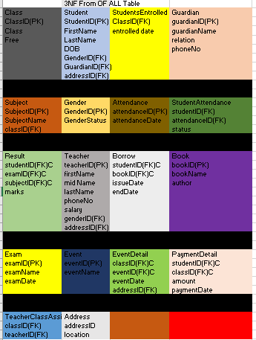

Figure : 3NF Form of all Tables

In an academy setting, implementing a third-normal form (3NF) database system is analogous to building a strictly ordered form system for all student-related information. This strategy organizes data, including student details, outcomes, and attendance, in discrete tables with clear linkages between them. The critical goal is to avoid unnecessary repetition of information, hence maintaining database thickness. Essentially, a 3NF database for an academy serves as a stable and effective means of managing student records, lowering crime rates and improving data trust.

In terms of the normalization procedure for our script, imagine a disorganized table of student information that resembles a chaotic room. The original state included dispersed details such as guardian names, phone numbers, and residences across rows. Normalization is used to manage disorder in three ways.

# **SQL of the normalized Tables.**

Create Database

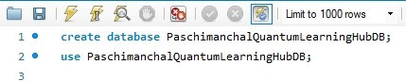

Figure :Create Database and Use Database

Create Table (Class, Gender, Address and Guardian)

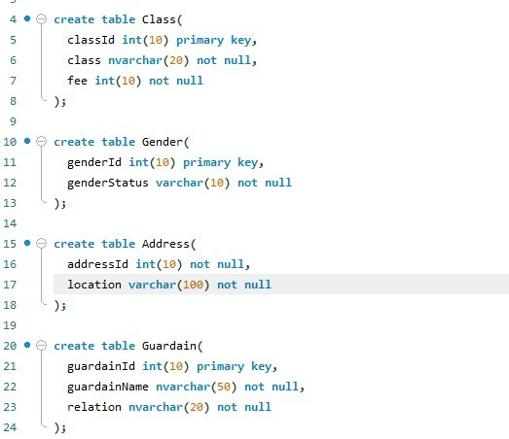

Figure : (Class, Gender, Address, Guardian) - Table

Create Table (Student, Teacher)

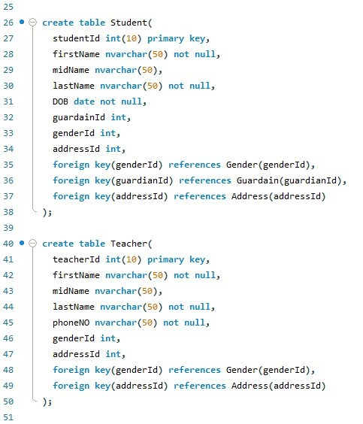

Figure (Student, Teacher)- Table

Create Table (Subject, Payment, Result)

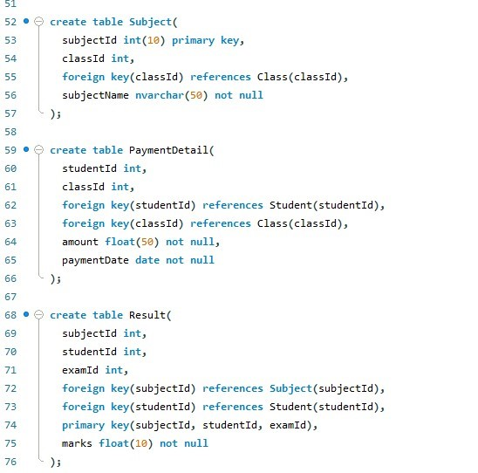

Figure (Subject, Payment, Result) - Table

Create Table (Exam, Borrow, Book, Attendance)

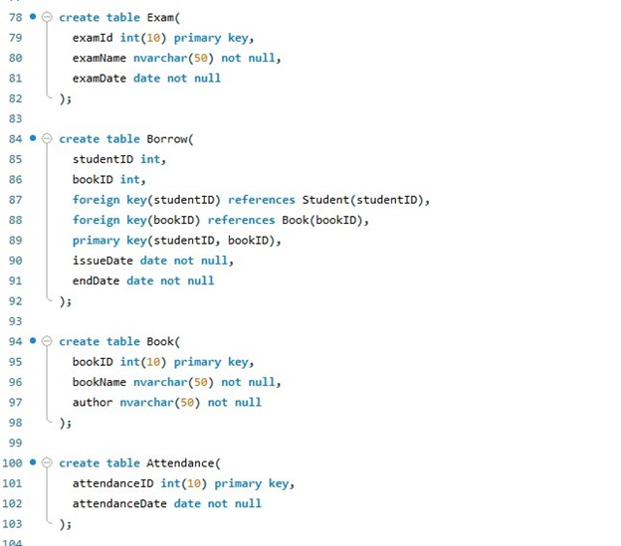

Figure ( Exam, Borrow, Book, Attendance) - Table

Create Table (Attendance, Events, Student Enrolled)

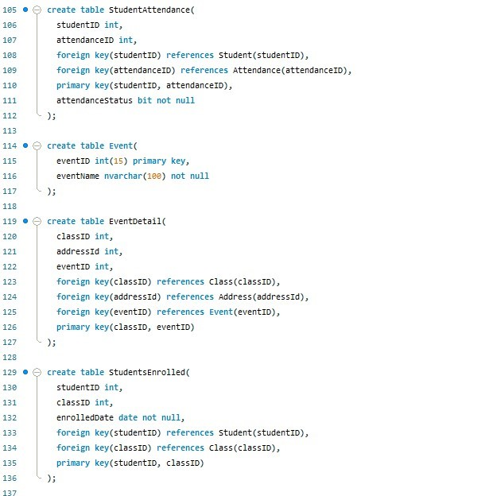

Figure (Attendance, Events, Students Enrolled) - Table

# **Data Entry for the Created Tables**

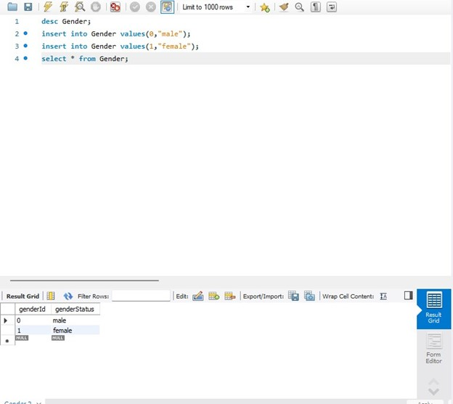

Figure Gender Entry

Guardian Data

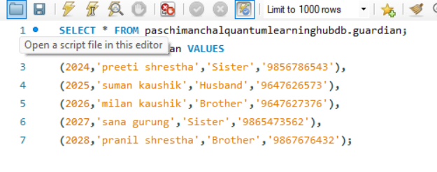

Figure Guardian Data

Address Data

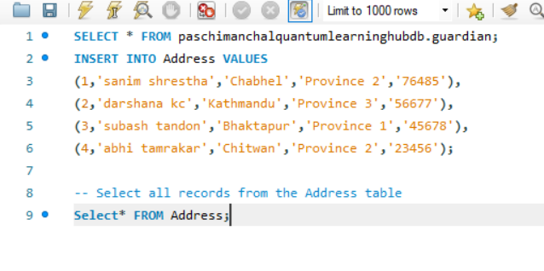

Figure Address Data

Class Data

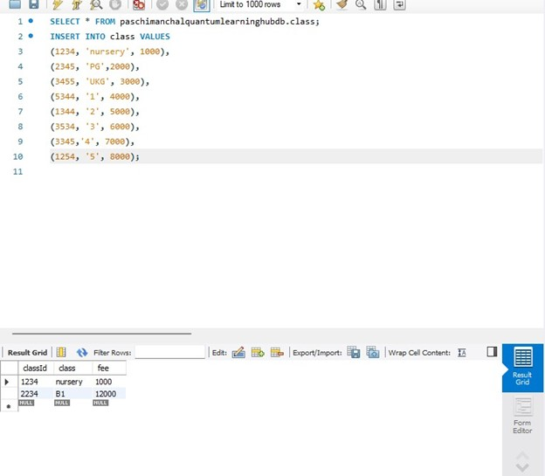

Figure Class Data

Student Data

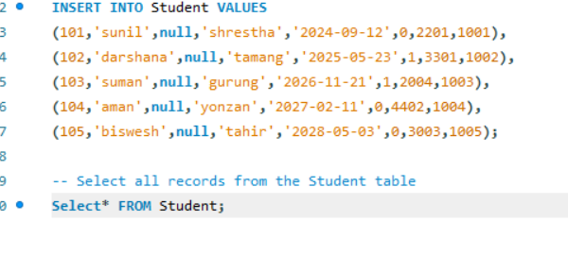  
Figure Student Data

Subject Data

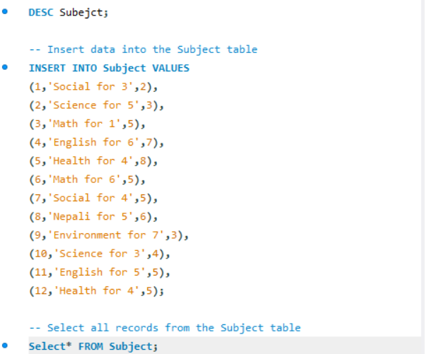

Figure Subject Data

Result Data

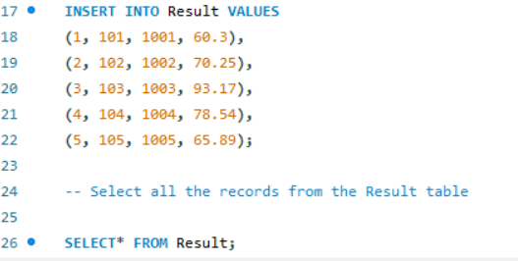

Figure Result Data

Payment Data

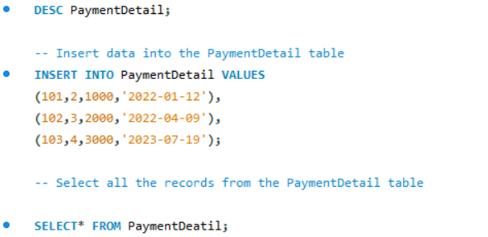

Figure Payment Data

Teachers Data

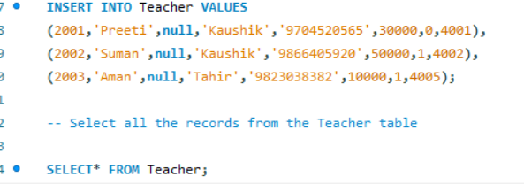

Figure Teachers Data

Event Data

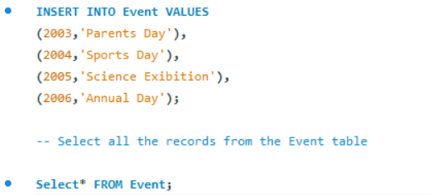

Figure Events Data

Event Details Data

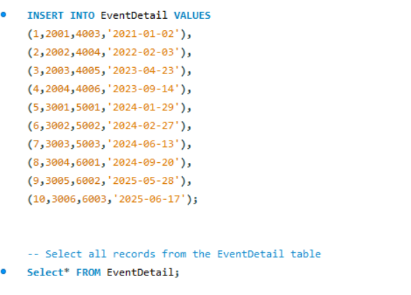

Figure Event Details Data

# **Data Visualization**

Bar Graph Code

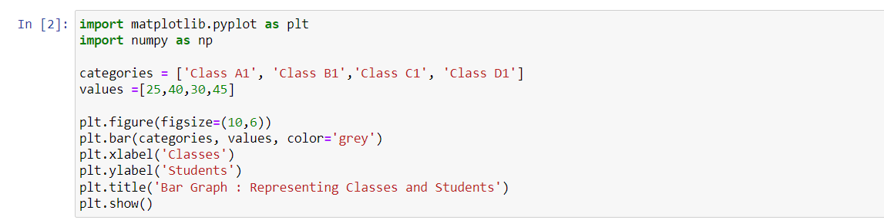

Figure Bar Graph Code

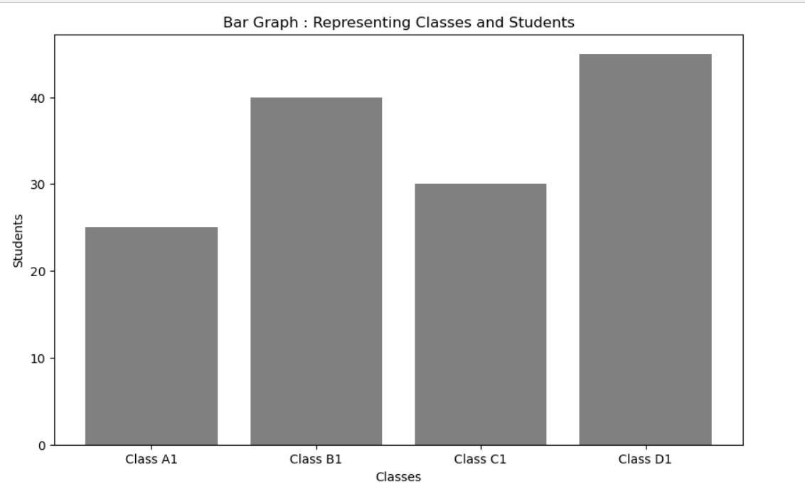

Figure Bar Graph representing class and students

Line Pot Graph Code

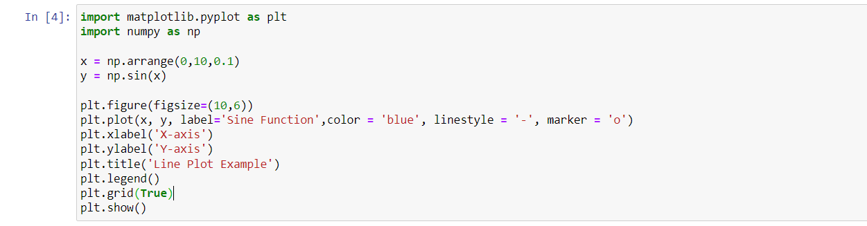

Figure Line Pot graph code

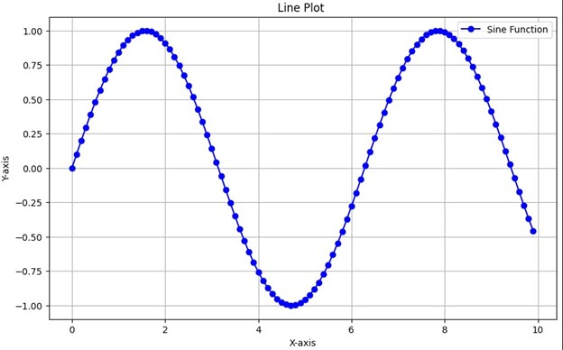

Figure Line Pot Representation

Distribution of values ratings code

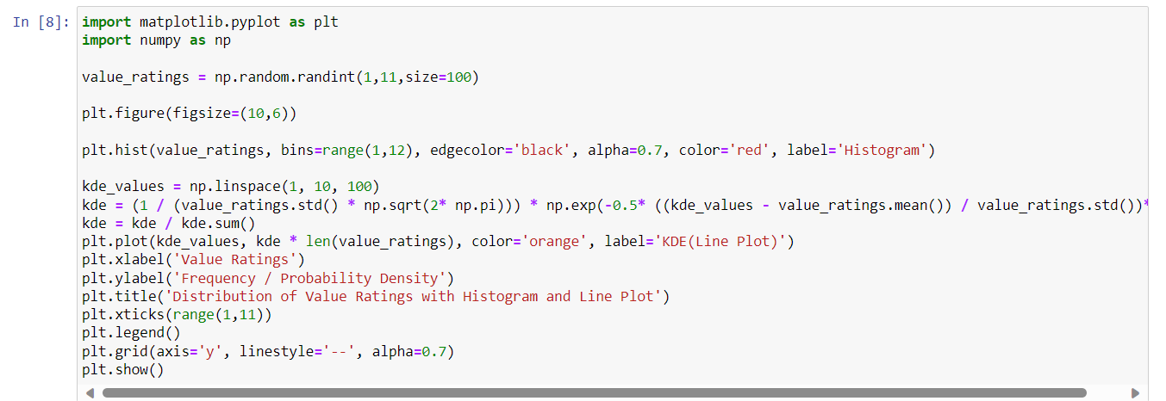

Figure Distribution of values ratings code

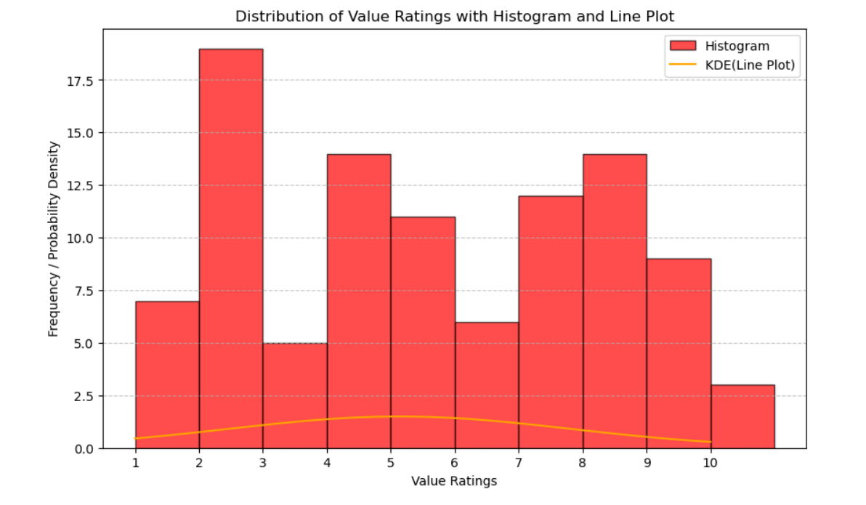

Figure Distribution of value

Average Service Ratings by Category Code

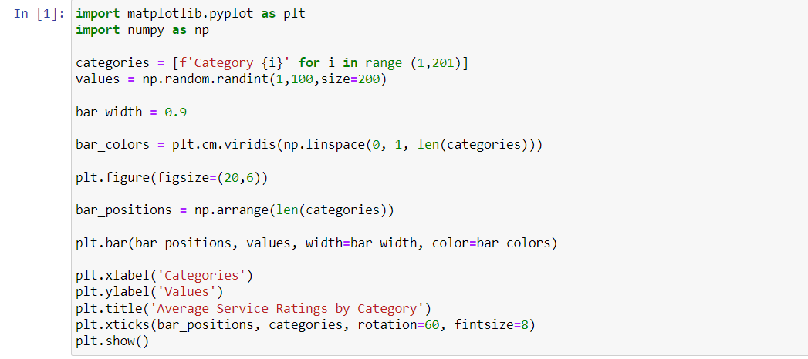

Figure Average Service Ratings by Category Code

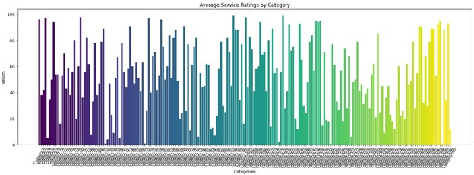

Figure Average Service Ratings by Category

Box Plot Code

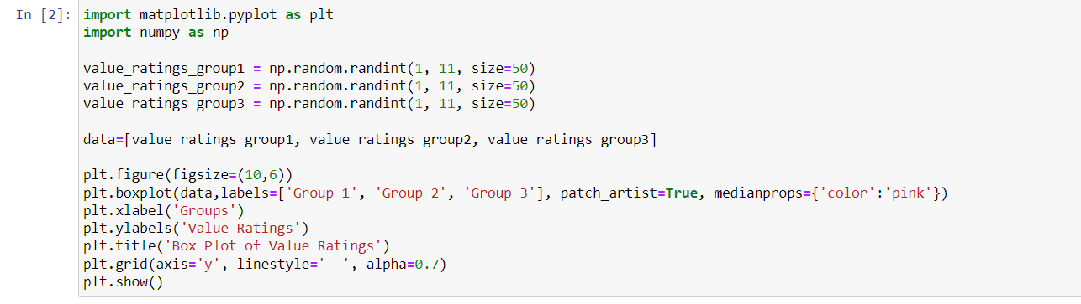

Figure Box Plot Code

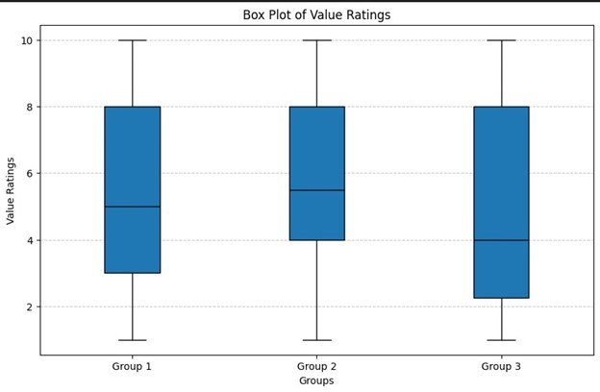

Figure box Plot graph

Pie Chart Code

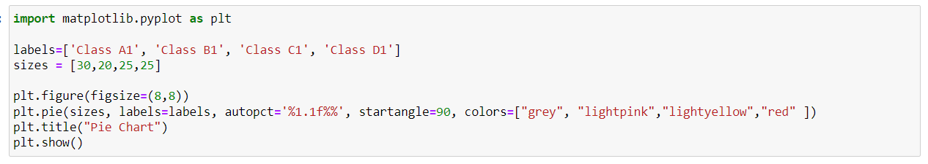

Figure Pie Chart Code

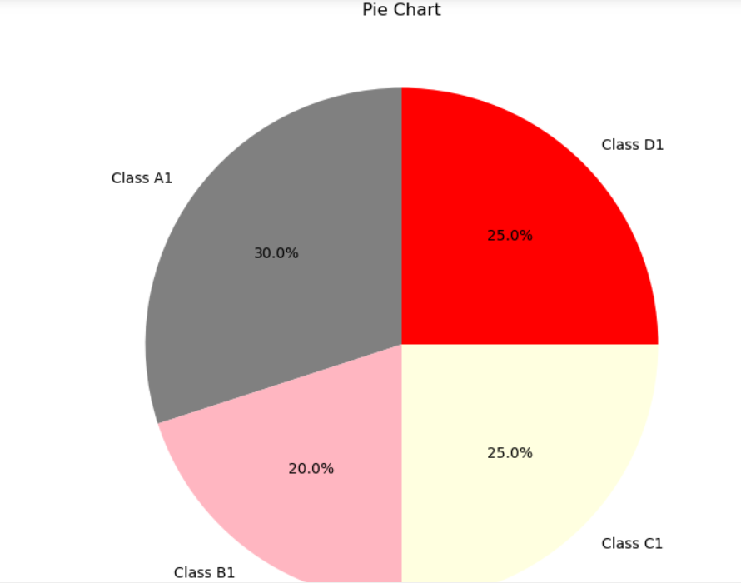

Figure Pie chart